Miss Ginger Golden, MSEd.
ggolden@portalesschools.com
(575) 356-7045
7th & 8th Media Arts
Course Syllabus

“I am always doing that which I cannot do, in order that I may learn how to do it.”
-Pablo Picasso-
Required Supplies
- 1 pack of loose leaf paper
- 1 Composition Notebook
- 1 Spiral Notebook
- Subject Dividers, at least five
- 1 inch Three-Ring Binder no bigger
- 2 packs of 3x5 index cards any color
- 1 Folder with Pockets and Brads (Plastic is preferred)
- (Optional, but helpful) 1 pack of Double A Batteries, Glue Sticks, Kleenex, or Clorox Wipes
Course Description
Media Arts is a full year class that is designed to introduce students to equipment and software used in the various areas of Media Production. I.e. iMovie, Garageband, and other related software.

Make-up and Late Work
Students will have as many days as they were absent to complete make-up assignments. Any work missed due to absences can be picked up before the absence or upon returning to the classroom.
Assignments turned in late, after the number of excused missed days, will receive a 60% or lower.
Student Expectations
- Evaluate the types of careers that are available in Media Production (i.e. film, television, & music and or audio)
- Evaluate the role media plays both economically and politically in American society
- Create outlines, storyboards and sets for completing media projects
- Learn and use basic music creation and video editing software such as iMovie and Garage Band
- Write scripts, design lighting, create musical soundtracks, and edit raw footage for a variety of projects including, but not limited to:
  - an emotion video montage, commercial, movie, PSA, interview, stop motion, music video, sports highlight reel
- Emphasis will be placed on work place behavior and standards, since this is a Career class.

Discipline
Any act that disrupts the educational process of any student is considered misconduct. The behavior will be logged. The consequences are as follows:
- Four Questions
- Call Home
- Behave Out = Referral
Hall Passes
Anytime a student leaves Miss Golden’s room for any reason, they must take the appropriate hall pass with them and wear the pass around their neck. In addition, the time the student leaves and returns to the classroom will be logged. Bathroom and drink passes are only allowed to be used TWICE PER WEEK. Any unused passes may not roll over to the next week or be turned in for E.C.
Progress Reports and Extra Credit
Progress reports will be sent out the beginning of each week. Miss Golden will highlight any missing work in the class color. In addition, she will circle any work that is eligible to be corrected for a higher grade. Lastly, Progress Reports will need to be signed and turned in for 50 points of extra credit. This is the only extra credit that will be given out during the school year.
Tardies
Students who are not in the room when the bell rings are considered tardy. A student receives a referral ON and after the third tardy.

Evaluations
- Teacher observation of student mastery of equipment and software (100 pts.)
- GOT Topics (100 pts.)
- Daily assignments (100 pts.)
- Educational videos from which the student will take notes (100 pts.)
- Written and/or oral tests and/or quizzes (100-200 pts.)
- Appropriateness & professionalism of completed project as evaluated by grading rubric supplied by the teacher (200 pts.)

Golden Nuggets
Come to class prepared.
Be courteous and respectful to everyone.
No food or drink in the classroom.
Follow all rules in the student handbook.
Say yes ma’am and no ma’am.
No answering with yeah, we utilize yes.

Miss Ginger Golden, MSEd.
ggolden@portalesschools.com
(575) 356-7045
7th & 8th Media Arts
Course Syllabus

You buy it if you break it or lose it.

Resources
Miss Golden loves technology and utilizes various websites and apps in order to help her students be successful. Feel free to check out some of the websites/apps she utilizes on a daily basis:
www.ggoldensclass.weebly.com http://classroom.google.com
Remind Homework App for 1st Hour: http://www.remind.com/join/1stggolden
Remind Homework App for 6th Hour: http://www.remind.com/join/6th ggolden

Communication – A Note to the Parents
Please feel free to contact Miss Golden when you have any questions or concerns. She feels e-mail is the best and easiest way for communication. Her e-mail address is ggolden@portalesschools.com. In addition, she emails her lesson plans out weekly. If you would like to get on this email list please write your email address on the next page. Furthermore, she keeps a Dropbox folder of all of her lessons plans and important handouts. If you would like her to add you to Dropbox, send her your email address and she will email you an invite. If you are not comfortable with e-mail please feel free to contact her by phone at 356-7097 extension 5105. The preferred times to reach her are before school or during my prep: 10:18-11:03 a.m.

Lifelong Learners

Lifelong learners are

Responsible
Self-Directed
Self-Motivated

Memorize this and practice this. Strive to get better at this each and every day.

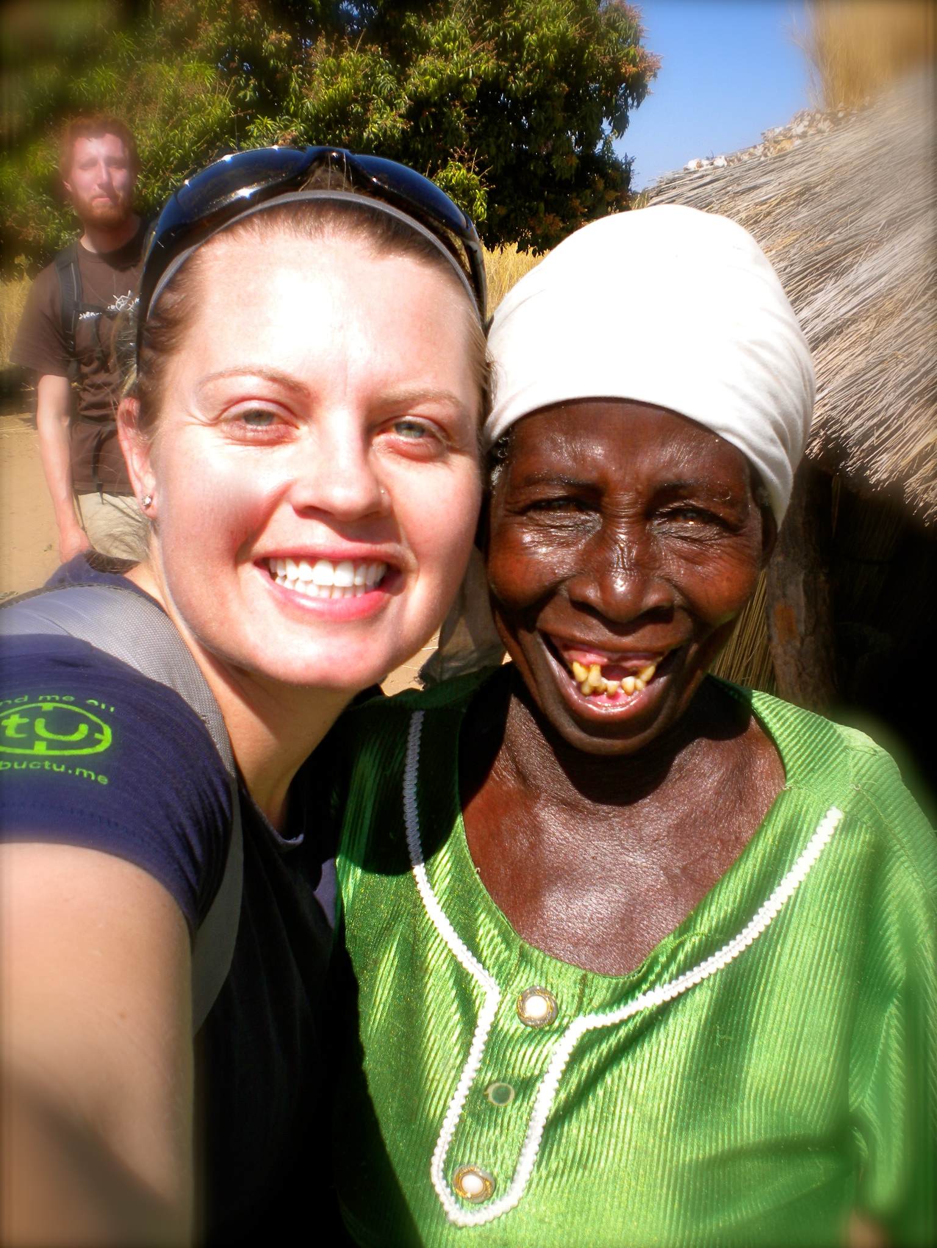

8/10/16
Hello,

My name is Ginger Golden and I am going to be one of your kiddo’s teachers this year at the Junior High. I have been blessed to teach at the Junior High for 13 years. I teach 8th grade English and 7th and 8th grade Media Arts. I coach 8th grade girls’ basketball and girl’s track.
Here is a little a bit about myself! I grew up on a small farm in Arch, New Mexico with my parents, two sisters, and one brother. I attended Portales Schools from kindergarten through high school where I actively participated in band (trumpet) and athletics. Once I graduated from Portales High School, I attended Wayland Baptist University where I had the opportunity to study and play basketball. Upon graduation, I was hired by Portales Schools to teach and coach. In my 13 years at PJHS, I received my Master of Science in Education from Walden University in 2009, and my TESOL (Teaching English to Students of Other Languages) Endorsement in 2013 in order to offer my students a higher quality of education.
Some activities I enjoy are being outside, especially in the mountains, fishing, camping, and riding dirt bikes. I love to snow ski, fix motorcycle engines, cook, bake, play guitar, play Rock Band, read my Bible, watch football, enjoy time with my family, and travel.
Speaking of travel, during the summers I have been extremely blessed to work with Overland Missions (www.overlandmissions.com) since 2011. I have been given the privilege of traveling to other countries as a missionary. I have spent many months in Zambia, but I have also been to South Africa, Zimbabwe, Botswana, the United Kingdom, Cambodia, Singapore, Thailand, and most recently Brazil. I have a heart for the nations, a heart for kids, and a heart for sharing my testimony with others.
If you’d like to know anything else about my travels, my classroom, or myself, please feel free to email or call (575-356-7045) and I would love to talk with you. I look forward to an amazing school year full of challenges, love, and learning. Have a blessed day!

Sincerely,

Ginger M. Golden

EXTRA CREDIT SHEET
Media Arts for 7th and 8th Graders
Miss Golden’s Class

Class Period: _____________

Printed Student Name: ___________________________________________________________

Student Signature: ______________________________________________________________

Printed Parent/Guardian Name: ___________________________________________________

Parent/Guardian Signature:_______________________________________________________

*Parents, please PRINT your email address(es) NEATLY:

_____________________________________________________________________________

_____________________________________________________________________________

*Would like to receive an email of my lesson plans weekly? (Please circle) YES or NO

*Would you like to receive an invitation to Dropbox? (Please circle) YES or NO
Directions to join the folder will be emailed upon invitation.

*Would you like to receive notifications on Remind about due dates? (Please circle) YES or NO
Directions to join the app will be emailed upon invitation.

*Comments or Questions:

